* In Borrower Details Update and Issue & Return book the photo of the student is not refreshing. Done
* Remove all messages showing in the Issue Return Book, Book bank and reference. Done
* In Borrower Details Update -- > Particular Student when we enter any student Id then it shows message (Error: Exception occurred, Transaction Failed). Done
* Invoicing & Accessioning --> Change Title or Delete Accession --> Select the Invoice and title --> In the accessioned book list for multiple delete need one button for Delete.
* For delete the book according to accession no. need one link in the Invoicing & Accessioning like change Title or Modify Title, then we select the accession no. from and to for delete.
* When we add multiple title for same Invoice no. or Bill No. every time for each title entry we have to select the Invoice no. so no need to refresh the Invoice only accessing part will be refresh then we can add multiple title but invoice no. select one time only… Done

**Date: 16/09/2014**

* In the Title Entry when we modify the subject is showing main subject code required.
* In the Main Subject when we Edit - Computer Done

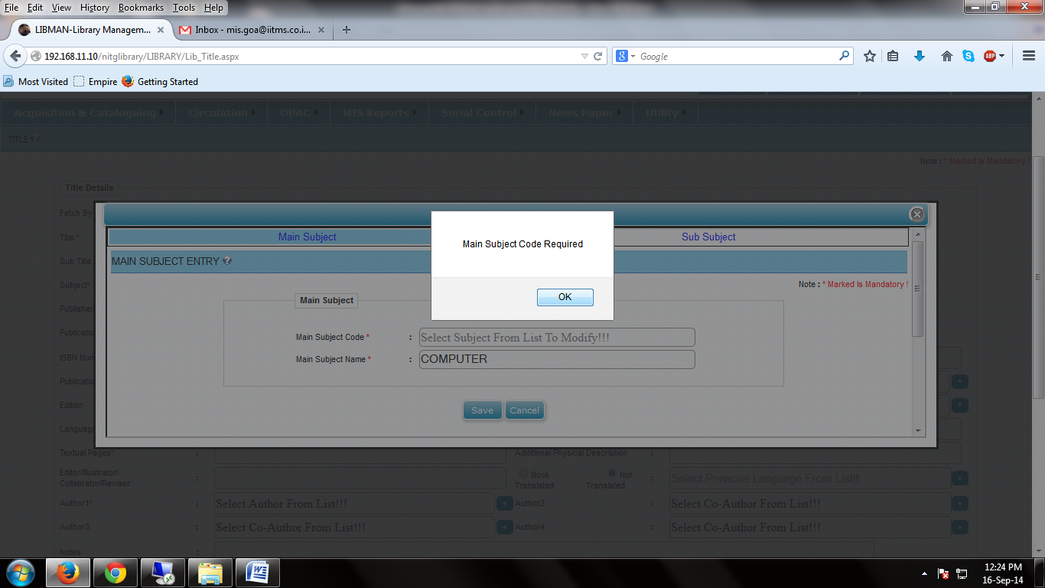

* The List for modify give rights on Sub Subject Name in the Sub Subject.
* If Borrower having BT STATUS Active then only show in the circulation. (When we select INACTIVE borrower it shows message).
* In New book arrival Details the From Date and To Date not mandatory user can search by select the series and give no. of record (Record will show by latest or new record).
* For B-Tech, M-Tech and PhD 1st Year student we have to data migrate from Academic to Library. Done
* In OPAC when search any book in the search result add one row for the edition. Work In Progress
* In the Title Entry when we enter the detail of publisher the city, State should not be mandatory.
* In Publisher entry special character are not taking- Allow to enter the Special character.
* Utility --> user creation/Authorization --> when we select user type faculty and student the list of the student or faculty is not showing in the search box. Done
* When we give new link to same employee then it showing the error "Error: Exception Occurred, Transaction fail ". Done
* In borrower Details --> The users are not filter according to selection of borrower member type and branch. Done
* Barcode Printing via Barcode printer -- > after click on ADD Button -- > Print1, Print2 and Download Button not working…. (When we connect with Barcode printer at that time all button work and print) Done
* In Transaction Report
* Remove the header and 0 margins for report print. Done
* The size of the barcode is vary it should be constant or standard size. Work In Progress
* The size of the barcode must be constant or standard size (In Spine Label, Barcode Generation Report)…. Work In Progress
* In Circulation ---> Reports -- > Transaction Report -- > When we select the Daily Transaction Report -- > the column NAME OF STUDENT replace with NAME OF USER…. Done
* Circulation --> Master --> Borrower Details Update
* In Borrower Details update need one Button for generate a report in Excel format according to selected option of Borrower Information. DONE
* OPAC ---> Search By ----> Author name change to Author DONE
* OPAC --->New Arrival ---> add to cart ---> Change the ACCNO to ACCN, TITLENAME to TITLE, AUTHORNAME to AUTHOR, PUBNAME to PUBLISHER, and DEPTNAME to DEPT. DONE

**Date: 19/07/2014**

Library OPAC has almost all the default feature of searching the catalogs of the medias available in library, and clause for claim is also given except claim clause/option is open and not secured, anyone can see and modify the lending status of any one, may be its of faculty, student, staff. Hence, lack of privacy and user may violate the rules by this existing software system. I would like get the following facility in our library OPAC:

* Login based system, so that password protected user account can't be open by others. It is very common feature available in all most all the library software.
* Purchase suggestion column and form for book recommendation should be in OPAC, the gateway of this facility should be controlled at the time of creating users, by library staff.
* Notice/updates column must be in OPAC.

***Old Points Corrections***

1. Provide the facility to download/export the bibliographic data in MARC format. It is needed for us for the Union catalog purpose.(30 June)
2. Title Page always refresh after each and every entry, which creates problem such as; makes process time taking, distract the vision from the exact place. When I wish to enter a single title, it takes more than 2 minutes in normal cases, it is not good and interest for work also goes.(14 July)